**CHAPTER 1**

**INTRODUCTION**

**A. COMPANY PROFILE**

***PAMANTASAN NG LUNGSOD NG MAYNILA***

On 19 June 1965, the final bill entitled "An Act Authorizing the City of Manila to Establish and Operate the University of the City of Manila and for Other Purposes" was signed into law by President Diosdado P. Macapacal in a signing ceremony in Malacañang Palace witnessed by Atty. Primitivo de Leon, Mayor Villegas, Congressman Ramon Mitra Jr., and its main sponsor in the House of Representatives, Congressman Albert. The law was captioned as Republic Act No. 4196 which now serves as the University Charter.

On February 5, 1970, then Executive Secretary Ernesto M. Maceda, by authority of then President Ferdinand Marcos, conveyed unto the City of Manila two (2) parcels of land owned by the Republic of the Philippines. Said real properties consist the area where PLM stands today. And as solemnly endeared and inscribed by every PLM member to his heart, the University formally opened the University College on Monday, 17 July 1967 with an initial enrollment of 556 outstanding and bright scholars carefully selected from the upper 10% of the various public high schools in Manila. Indeed, excellence has been a "birthright" of PLM. The PLM also established the Graduate College a year later, followed by the Institute for Extra-Mural Studies. And the rest was history in the making.

**B. WHAT IS THE SYSTEM ALL ABOUT**

This System is about the Information Management of PFMO (Physical Facilities Management Office) of Pamantasan ng Lungsod ng Maynila. From adding, to editing, and deleting of Sections, Section Heads, Inventory, and Personnel tasks. It can also archive old blueprints, reports, memos, and other important documents needed for future reference. Report Generation is also a part of this system. It is generated from the information that has been added or changed from the system. Sections are the different sections that are under PFMO. Section Heads are the people who are in-charge of the different sections. Inventory holds the list, quantity, categories, and descriptions of the items or supplies under PFMO. Personnel tasks are the different tasks or duties that are assigned to the personnel of PFMO.

**C. STATEMENT OF THE PROBLEM**

**Problem 1:** Slow and Tedious process of borrowing and returning of items and equipment.

**Problem 2:** No existing process of tracking of special project supplies.

**Problem 3:** Management receives no real time update from the custodians for each tools, equipment and supplies issued or returned.

**D. OBJECTIVES**

**GENERAL OBJECTIVES**

The main objectives of the study are to apply the principle and concepts to provide a solution to the existing problems of the company and provide an automated management system for the Pamantasan ng Lungsod ng Maynila, Physical Facilities and Management Office Inventory and Supplies Management and Tracking Section.

**SPECIFIC OBJECTIVES**

The specific objectives of the study based on the problems stated:

* 1. To immediately check tools and equipment quantity in the inventory.
  2. To directly track and monitor outgoing equipment, tools and supplies.
  3. To update the Chief PFMO of received and issued equipment, tools and supplies from the three property sections (Special Projects, Quarterly Supplies, Equipment and Tools).

**E. SCOPE AND LIMITATIONS**

This study is about the Management Information System of PFMO in Pamantasan ng Lungsod ng Maynila. The focus of this is only about the management of information such as the sections, inventory, personnel, archives and reports and all the other processes that are not covered and irrelevant to the system is out of our scope and out of our bounds to be discussed. Transactions such as borrowing and returning of items can be added upon request from PFMO chief.

**CHAPTER 2**

**SYSTEM ANALYSIS**

**A.DATA DICTIONARY**

**DATA DICTIONARY** - A data dictionary is a collection of descriptions of the data objects or items in a data model for the benefit of programmers and others who need to refer to them. A first step in analyzing a system of objects with which users interact is to identify each object and its relationship to other objects.

**DATA DICTIONARY**

**SectionTable**

|  |  |  |  |
| --- | --- | --- | --- |
| Field Data | Field Type | Length | Description |
| SectionID | **Guid** | **32** | **Section Code** |
| SectionName | **Text** | **200** | **Name of Section** |
| SectionType | **Text** | **200** | **Type of Section** |
| SectionDescription | **Text** | **200** | **Description of Section** |
| SectionDateCreated | **DateTime** | **20** | **Date of the creation of Section** |

**SectionHeadTable**

|  |  |  |  |
| --- | --- | --- | --- |
| Field Data | Field Type | Length | Description |
| SectionHeadID | **Guid** | **32** | **Section Head Code** |
| SectionHeadLastName | **Text** | **200** | **Last name of Section Head** |
| SectionHeadFirstName | **Text** | **200** | **First name of Section Head** |
| SectionHeadGender | **Text** | **10** | **Gender of Section Head** |
| SectionHeadDesignationID | **Guid** | **32** | **Section Head Designation Code** |
| SectionHeadRemarks | **Text** | **200** | **Remarks of the Section Head** |
| SectionID | **Guid** | **32** | **Section Code** |
| SectionHeadHireDate | **DateTime** | **20** | **Hire date of the Section Head** |
| SectionHeadContactNumber | **Number** | **20** | **Contact number of Section Head** |

**SectionTaskTable**

|  |  |  |  |
| --- | --- | --- | --- |
| Field Data | Field Type | Length | Description |
| SectionTaskID | **Guid** | **32** | **Section Task Code** |
| SectionTaskTitle | **Text** | **200** | **Task title of Section** |
| SectionTaskDescription | **Text** | **200** | **Task description of the Section** |
| SectionID | **Guid** | **32** | **Section code** |
| SectionTaskStartDate | **DateTime** | **20** | **Start Date of the Task of the Section** |
| SectionTaskEndDate | **DateTime** | **20** | **End Date of the Task of the Section** |

**SectionHeadDesignationTable**

|  |  |  |  |
| --- | --- | --- | --- |
| Field Data | Field Type | Length | Description |
| SectionHeadDesignationID | **Guid** | **32** | **Section Head Designation code** |
| SectionHeadDesignationName | **Text** | **200** | **Name of the Designation for the Section Head** |
| SectionHeadDesignationDescription | **Text** | **200** | **Description of the Designation for the Section Head** |

**PersonnelTable**

|  |  |  |  |
| --- | --- | --- | --- |
| Field Data | Field Type | Length | Description |
| PersonnelID | **Guid** | **32** | **Personnel code** |
| PersonnelLastName | **Text** | **200** | **Last name of Personnel** |
| PersonnelFirstName | **Text** | **200** | **First name of Personnel** |
| PersonnelGender | **Text** | **10** | **Gender of Personnel** |
| PersonnelDesignationID | **Guid** | **32** | **Personnel Designation code** |
| PersonnelRemarks | **Text** | **200** | **Remarks of the Personnel** |
| SectionID | **Guid** | **32** | **Section code** |
| ProjectTeamID | **Guid** | **32** | **Project Team code** |
| PersonnelHireDate | **DateTime** | **20** | **Hire date of the Personnel** |
| PersonnelContactNumber | **DateTime** | **20** | **Contact number of the personnel** |

**PersonnelDesignationTable**

|  |  |  |  |
| --- | --- | --- | --- |
| Field Data | Field Type | Length | Description |
| PersonnelDesignationID | **Guid** | **32** | **Personnel Designation code** |
| PersonnelDesignationName | **Text** | **200** | **Name of the Designation for the Personnel** |
| PersonnelDesignationDescription | **Text** | **200** | **Description of the Designation for the Personnel** |

**PersonnelTaskTable**

|  |  |  |  |
| --- | --- | --- | --- |
| Field Data | Field Type | Length | Description |
| PersonnelTaskID | **Guid** | **32** | **Personnel Task code** |
| PersonnelTaskTitle | **Text** | **200** | **Title of the Personnel task** |
| PersonnelTaskDescription | **Text** | **200** | **Description of the Personnel task** |
| PersonnelID | **Guid** | **32** | **Personnel code** |
| PersonnelTaskStartDate | **DateTime** | **20** | **Start date of the Personnel task** |
| PersonnelTaskEndDate | **DateTime** | **20** | **End date of the Personnel task** |

**ProjectTeamTable**

|  |  |  |  |
| --- | --- | --- | --- |
| Field Data | Field Type | Length | Description |
| ProjectTeamID | **Guid** | **32** | **Project Team code** |
| ProjectTeamName | **Text** | **200** | **Name of Project Team** |
| ProjectTeamDescription | **Text** | **200** | **Description of Project Team** |
| ProjectID | **Guid** | **32** | **Project code** |

**ProjectTable**

|  |  |  |  |
| --- | --- | --- | --- |
| Field Data | Field Type | Length | Description |
| ProjectID | **Guid** | **32** | **Project code** |
| ProjectName | **Text** | **200** | **Name of project** |
| ProjectStatus | **Text** | **200** | **Status of the project** |
| ProjectCompletion | **integer** | **100** | **Completion of the project** |
| ProjectStartDate | **DateTime** | **20** | **Start date of the project** |
| ProjectEndDate | **DateTime** | **20** | **End date of the project** |

**SupplyTable**

|  |  |  |  |
| --- | --- | --- | --- |
| Field Data | Field Type | Length | Description |
| SupplyID | **Guid** | **32** | **Supply code** |
| SupplyCode | **Text** | **200** | **Code of the item supply** |
| SupplyName | **Text** | **200** | **Name of supply** |
| SupplyCategoryID | **Guid** | **32** | **Supply Category code** |
| SupplyRemarks | **Text** | **200** | **Remarks of the supply** |
| SupplyStatus | **Text** | **200** | **Status of the Supply** |
| SupplyBalance | **integer** | **200** | **Remaining balance of the supply** |
| SupplyUnit | **Text** | **200** | **Unit of measure of the supply** |
| SupplyReorderPoint | **integer** | **200** | **Reorder point of the supply** |
| Target | **Text** | **200** | **Target for the supply** |
| ProjectID | **Guid** | **32** | **Project code** |
| SupplyExpiryDate | **DateTime** | **20** | **Expiry date of the supply** |

**SupplyCategoryTable**

|  |  |  |  |
| --- | --- | --- | --- |
| Field Data | Field Type | Length | Description |
| SupplyCategoryID | **Guid** | **32** | **Supply category code** |
| SupplyCategoryName | **Text** | **200** | **Name of the supply category** |
| SupplyCategoryDescription | **Text** | **200** | **Description of the supply category** |

**EquipmentTable**

|  |  |  |  |
| --- | --- | --- | --- |
| Field Data | Field Type | Length | Description |
| EquipmentID | **Guid** | **32** | **Equipment code** |
| EquipmentCode | **Text** | **200** | **Code of the equipment** |
| EquipmentName | **Text** | **200** | **Name of equipment** |
| EquipmentCategoryID | **Guid** | **32** | **Equipment Category code** |
| EquipmentRemarks | **Text** | **200** | **Remarks of equipment** |
| EquipmentStatus | **Text** | **200** | **Status of the equipment** |
| EquipmentBalance | **integer** | **200** | **Remaining balance of the item** |
| EquipmentUnit | **Text** | **200** | **Unit of measure of the item** |
| EquipmentReorderPoint | **integer** | **200** | **Reorder point of the equipment** |
| Target | **Text** | **200** | **Target for equipment** |
| SupplyExpiryDate | **DateTime** | **20** | **Expiry supply date** |

**EquipmentCategoryTable**

|  |  |  |  |
| --- | --- | --- | --- |
| Field Data | Field Type | Length | Description |
| EquipmentCategoryID | **Guid** | **32** | **Equipment Category code** |
| EquipmentCategoryName | **Text** | **200** | **Category name of equipment** |
| EquipmentCategoryDescription | **Text** | **200** | **Description of equipment category** |

**ContactTable**

|  |  |  |  |
| --- | --- | --- | --- |
| Field Data | Field Type | Length | Description |
| ContactID | **Guid** | **32** | **Contact code** |
| ContactName | **Text** | **50** | **Name of the contact person** |
| ContactDescription | **Text** | **100** | **Description of the contact person** |
| ContactType | **Text** | **30** | **Type of contact person** |
| ContactOffice | **Text** | **50** | **Office of the contact person** |
| ContactEmail | **EmailAddress** | **50** | **Email address of the contact person** |
| ContactNumber | **PhoneNumber** | **20** | **Phone number of the contact person** |

**PinboardTable**

|  |  |  |  |
| --- | --- | --- | --- |
| Field Data | Field Type | Length | Description |
| PinboardID | **Guid** | **32** | **Pinboard code** |
| PinboardName | **Text** | **200** | **Name of the Pinboard** |
| PinboardContent | **Text** | **200** | **Content of the Pinboard** |
| PinboardDate | **DateTime** | **20** | **Date of the Pinboard** |

**B. RELATIONAL DATABASE**

A relational database - is a digital database whose organization is based on the relational model of data, as proposed by E.F. Codd in 1970. The various software systems used to maintain relational databases are known as relational database management system (RDBMS). Virtually all relational database systems use SQL (Structured Query Language) as the language for querying and maintaining the database.

**RELATIONAL DATABASE**

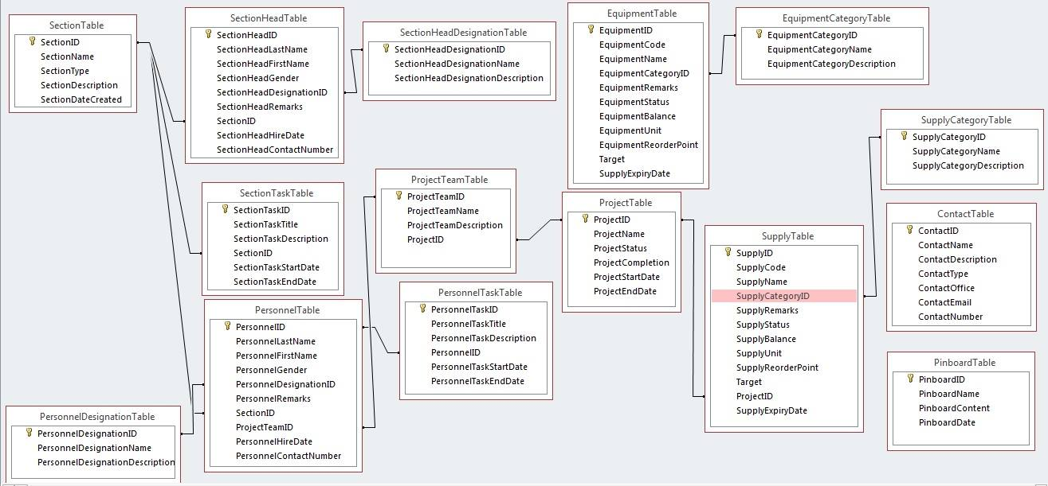

**C.NORMALIZATION**

**NORMALIZATION-** Database normalization (or normalisation) is the process of organizing the columns (attributes) and tables (relations) of a relational database to minimize data redundancy.

**UNF**

|  |
| --- |
| Section |
| Section Head |
| Section Task |
| Section Designation |
| Personnel |
| Personnel Task |
| Personnel Designation |
| Project |
| Project Team |
| Supply |
| Supply Category |
| Equipment |
| Equipment Category |

|  |
| --- |
| Section |
| Section Head |
| Section Task |
| Section Designation |
| Personnel |
| Personnel Task |
| Personnel Designation |
| Project |
| Project Team |
| Supply |
| Supply Category |
| Equipment |
| Equipment Category |

**1NF**

|  |
| --- |
| Section_Code |
| Section_Head |
| Section_Task |
| Section_Designation |

|  |
| --- |
| Equipment |
| Equipment_Category |

|  |
| --- |
| Section_Code |
| Personnel |
| Personnel_Task |
| Personnel_Designation |

|  |
| --- |
| Project_Code |
| Project_Team |
| Project |

|  |
| --- |
| Project_Code |
| Supply |
| Supply_Category |

**2NF**

**3NF**

**Section_TBL Section_Head_TBL Section_Task_TBL Section_Head_Designation_TBL**

|  |
| --- |
| ID |
| Name |
| Type |
| Description |
| Date Created |

|  |
| --- |
| ID |
| Last_Name |
| First_Name |
| Gender |
| Designation_ID |
| Remarks |
| Section_ID |
| Hire_Date |
| Contact_No |

|  |
| --- |
| ID |
| Title |
| Description |
| Start_Date |
| End_Date |

|  |
| --- |
| ID |
| Name |
| Description |

**Personnel_TBL Personnel_Designation_TBL Personnel_Task_TBL Project_Team_TBL**

|  |
| --- |
| ID |
| Last_Name |
| First_Name |
| Gender |
| Designation_ID |
| Remarks |
| Section_ID |
| Project_Team_ID |
| Hire_Date |
| Contact_No |

|  |
| --- |
| ID |
| Title |
| Description |
| Personnel_ID |
| Start_Date |
| End_Date |

|  |
| --- |
| ID |
| Name |
| Description |
| Project_ID |

|  |
| --- |
| ID |
| Name |
| Description |

**Project_TBL Supply_TBL Supply_Category_TBL Equipment_TBL**

|  |
| --- |
| ID |
| Name |
| Status |
| Completion |
| Start_Date |
| End_Date |

|  |
| --- |
| ID |
| Code |
| Name |
| Category_ID |
| Remarks |
| Status |
| Balance |
| UNIT |
| ReOrder_Point |
| Target |
| Project_ID |
| Expiry_Date |

|  |
| --- |
| ID |
| Name |
| Description |

|  |
| --- |
| ID |
| Code |
| Name |
| Category_ID |
| Remarks |
| Status |
| Balance |
| UNIT |
| ReOrder_Point |
| Target |
| Supply_Expiry_Date |

**Equipment_Category_TBL Contact_TBL Pinboard_TBL**

|  |
| --- |
| ID |
| Name |
| Description |
| Type |
| Office |
| Email |
| Contact_Number |

|  |
| --- |
| ID |
| Name |
| Content |
| Date |

|  |
| --- |
| ID |
| Name |
| Description |

**CHAPTER 3**

**GENERAL DESIGN**

**A. System Flowchart**









































B. Entity Relationship Diagram (**AS A WHOLE)**



Entity Relationship Diagram (**PER TRANSACTION)**

* Log in

User

has

User Log in

User Role

* Register

Role

Role Manager

User

User Manager

creates

creates

* Human Resources

contains

Personnel

Section Heads

Section

has

* Inventory

Equipment

Supply

Supply Category

contains

Equipment Category

contains

* Projects

assigned to

composes of

Project Team

Project

Personnel

contains

Supply

* Task Assignments

assigned to

assigned to

Section Task

Personnel

Section

contains

Personnel Task

**CHAPTER 4**

**Graphical User Interface (GUI)**

**Landing Page**

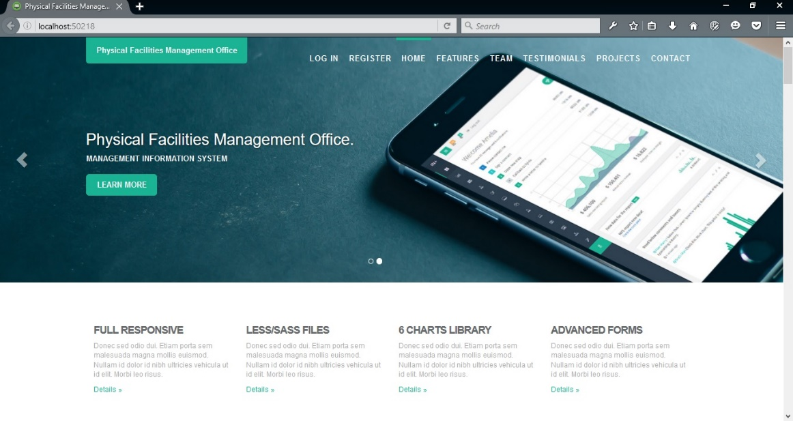

**Log-in Page**

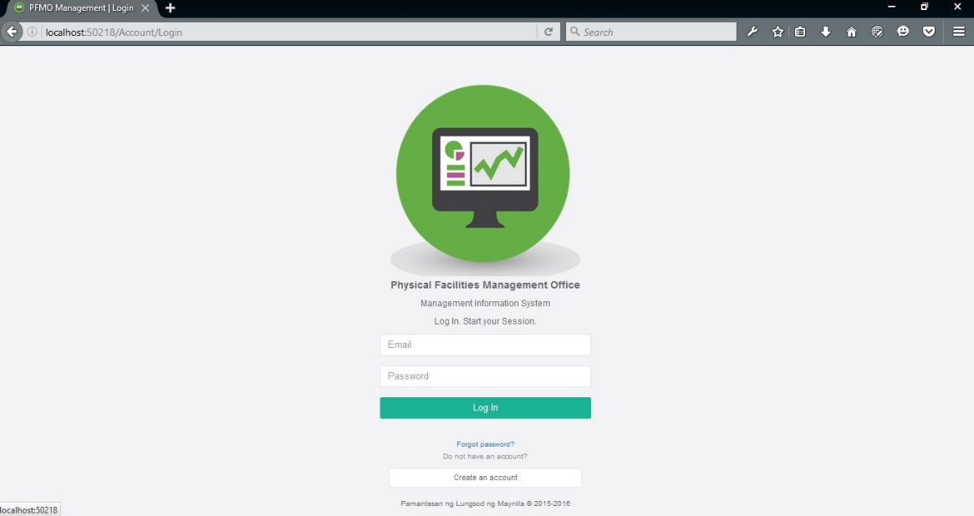

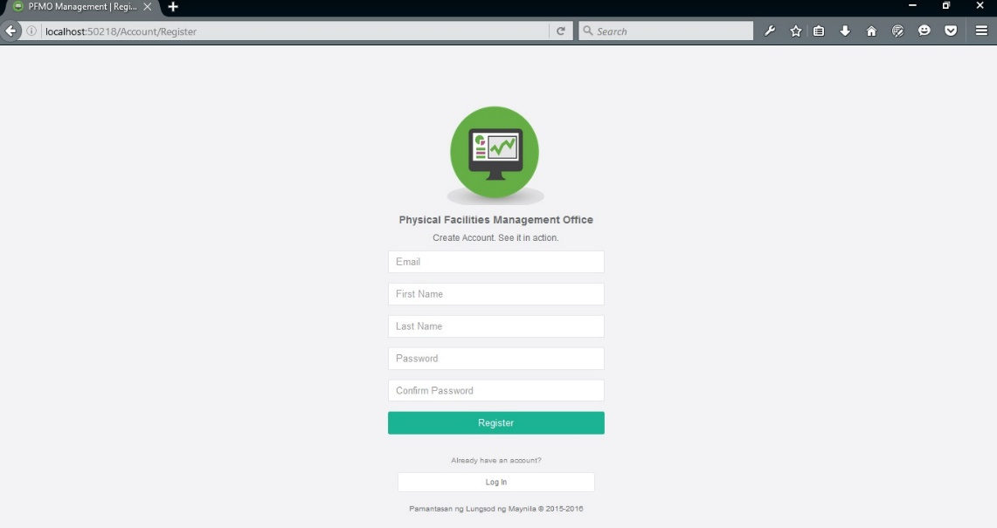**Register Page**

**Home Page**

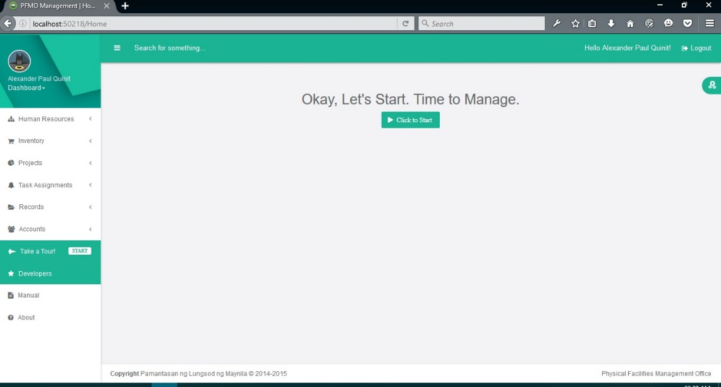

1. **Human Resources**

**Manage Sections**

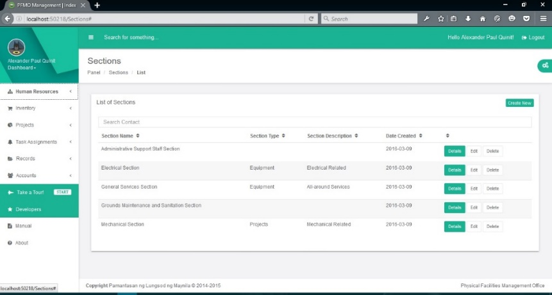

**Manage Section Heads**

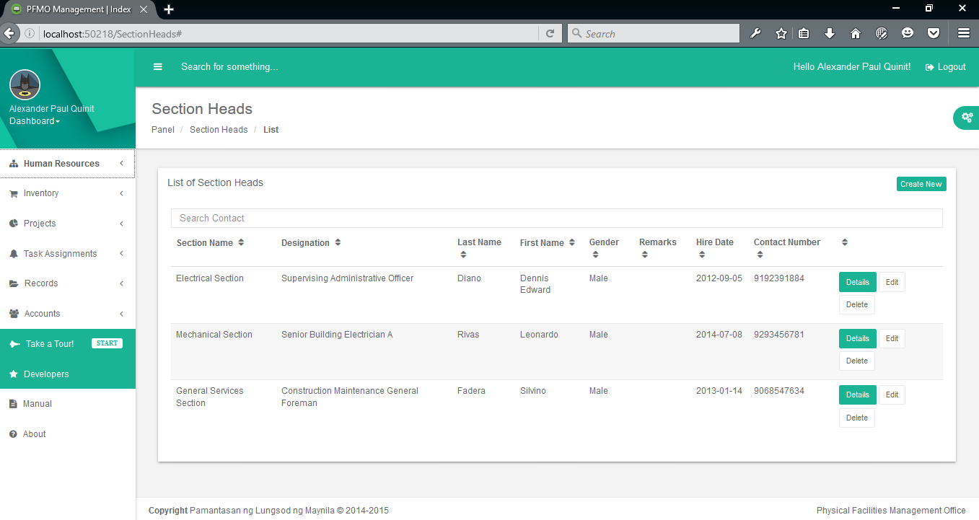

**Manage Personnel**

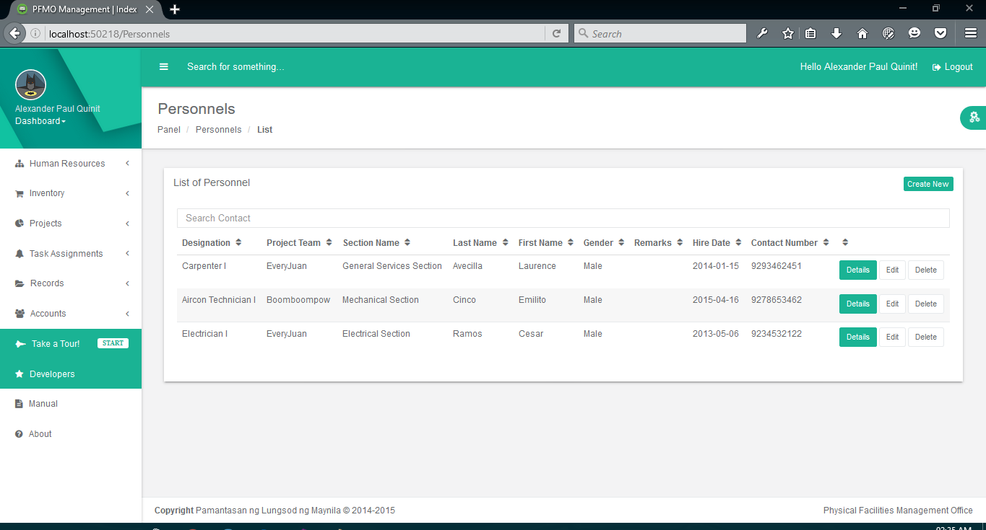

**Manage Designation**

**Personnel Designation**

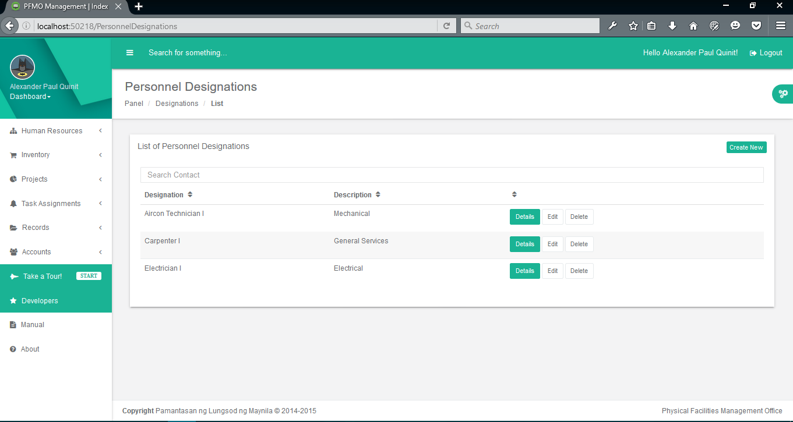

**Section Head Designation**

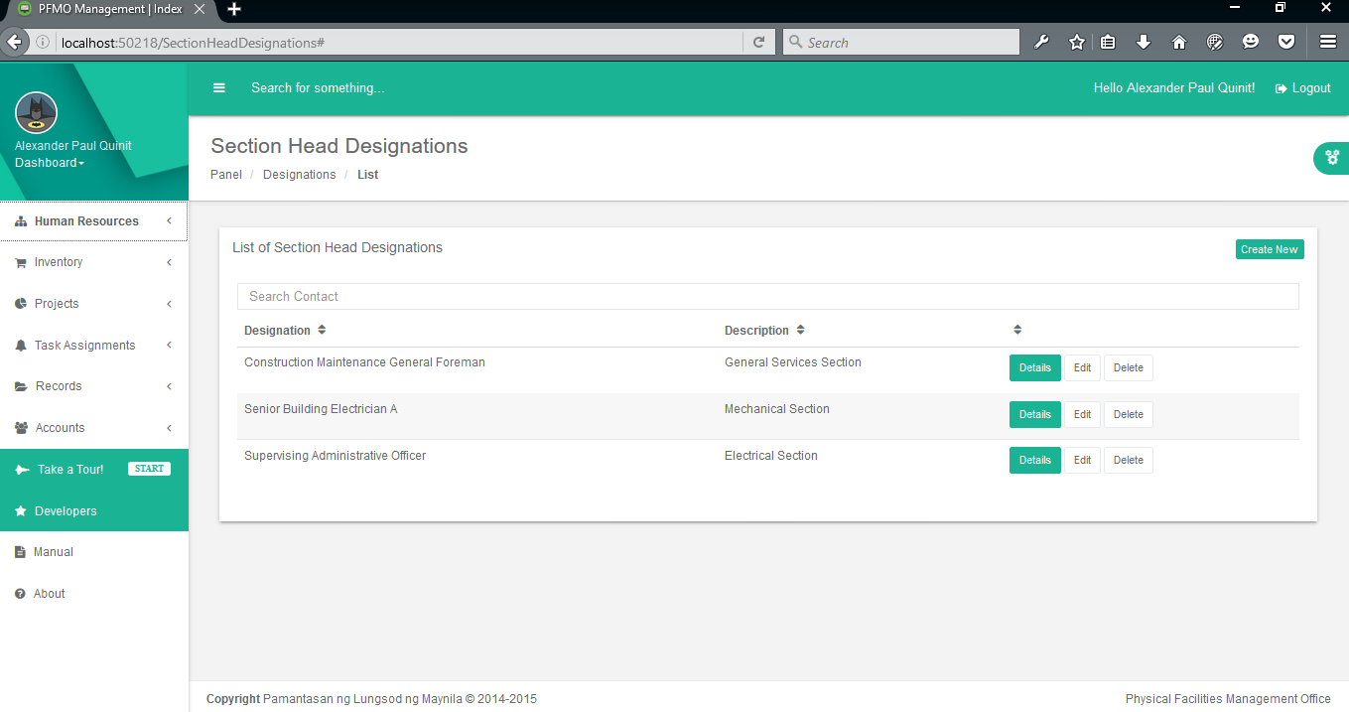

1. **Inventory**

**Manage Categories**

**Equipment Category**

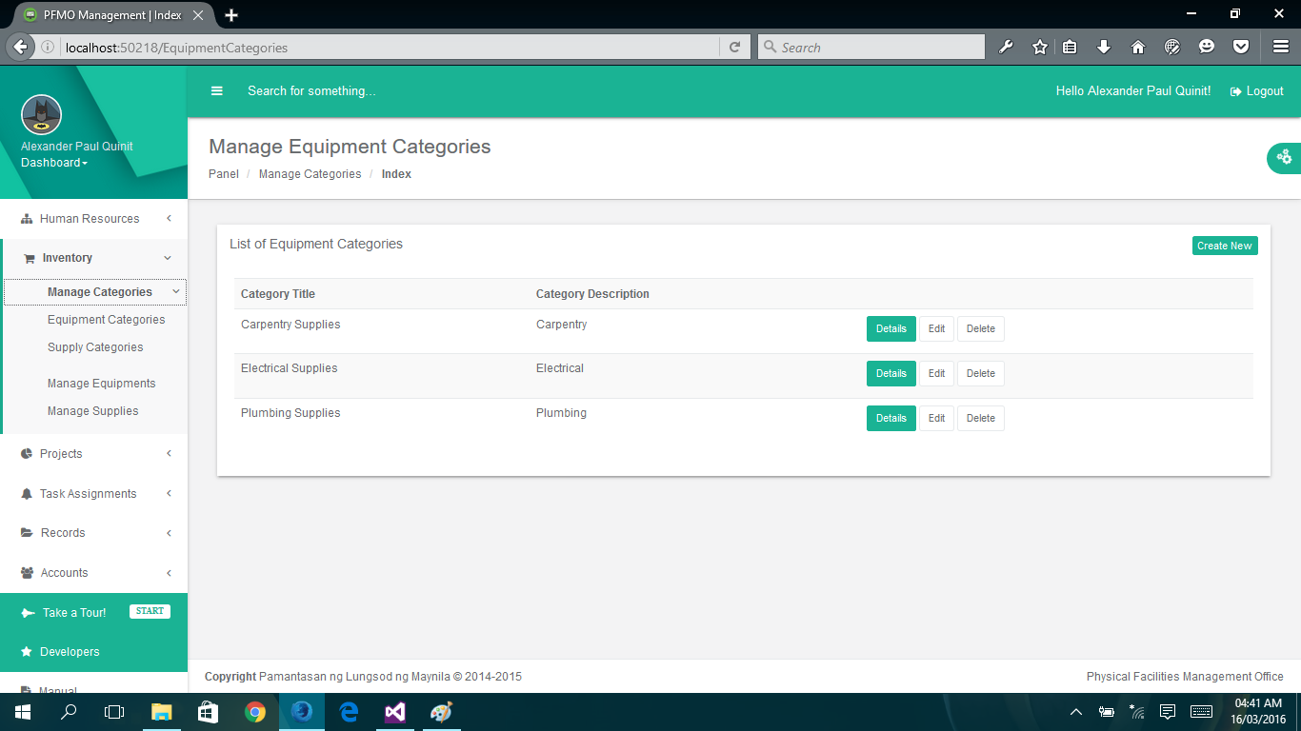

**Supply Category**

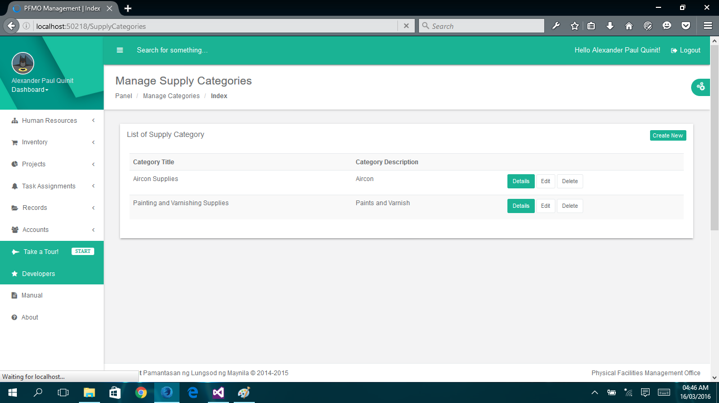

**Manage Equipment**

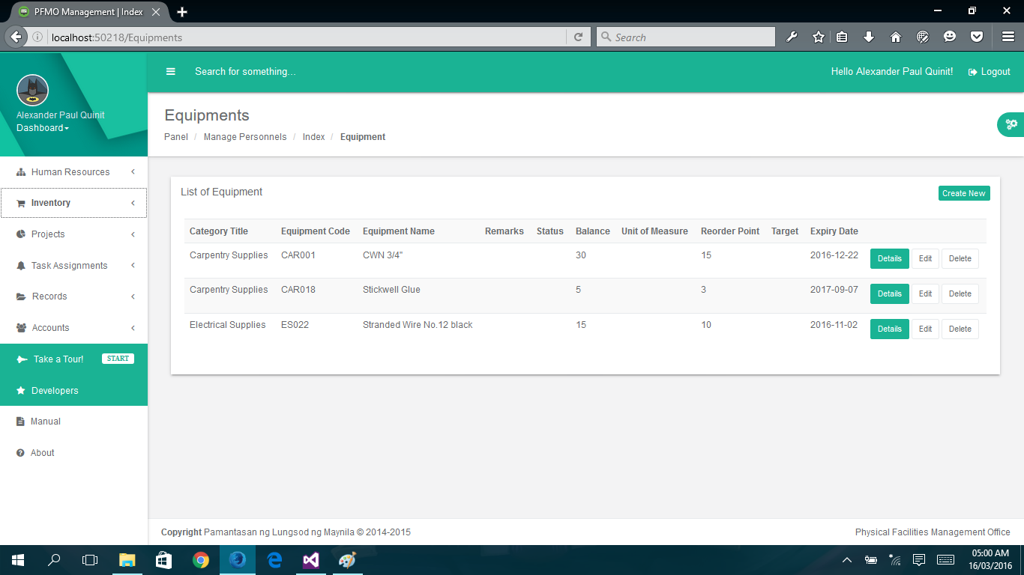

**Manage Supply**

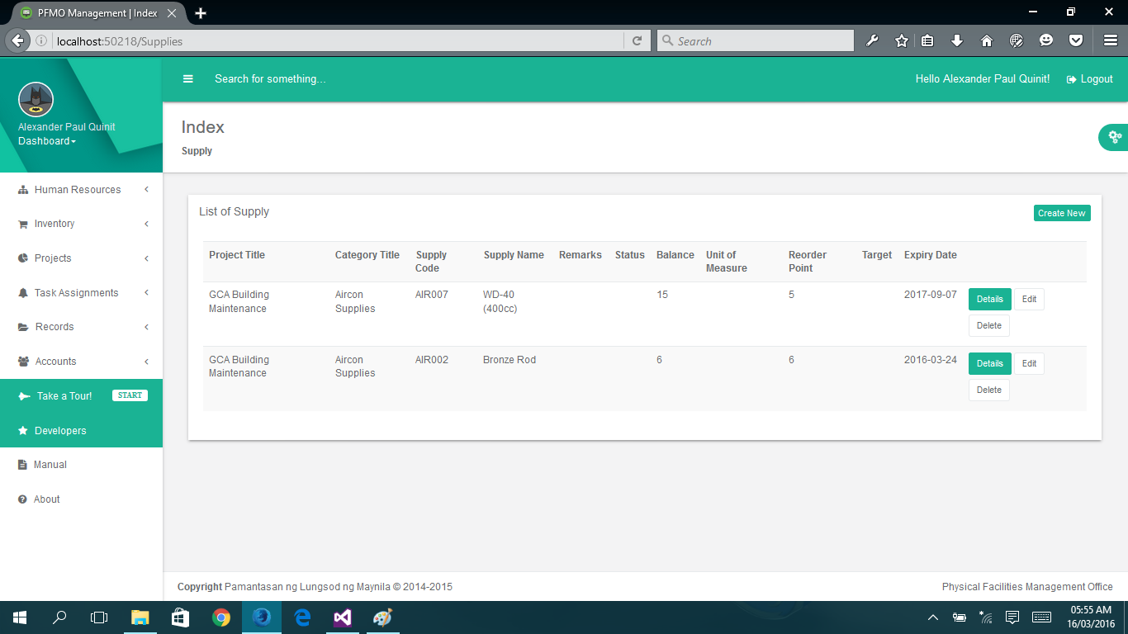

1. **Projects**

**Manage Teams**

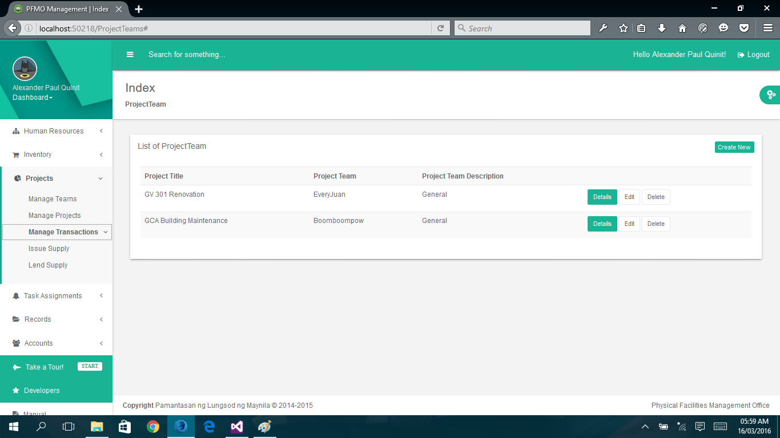

**Manage Projects**

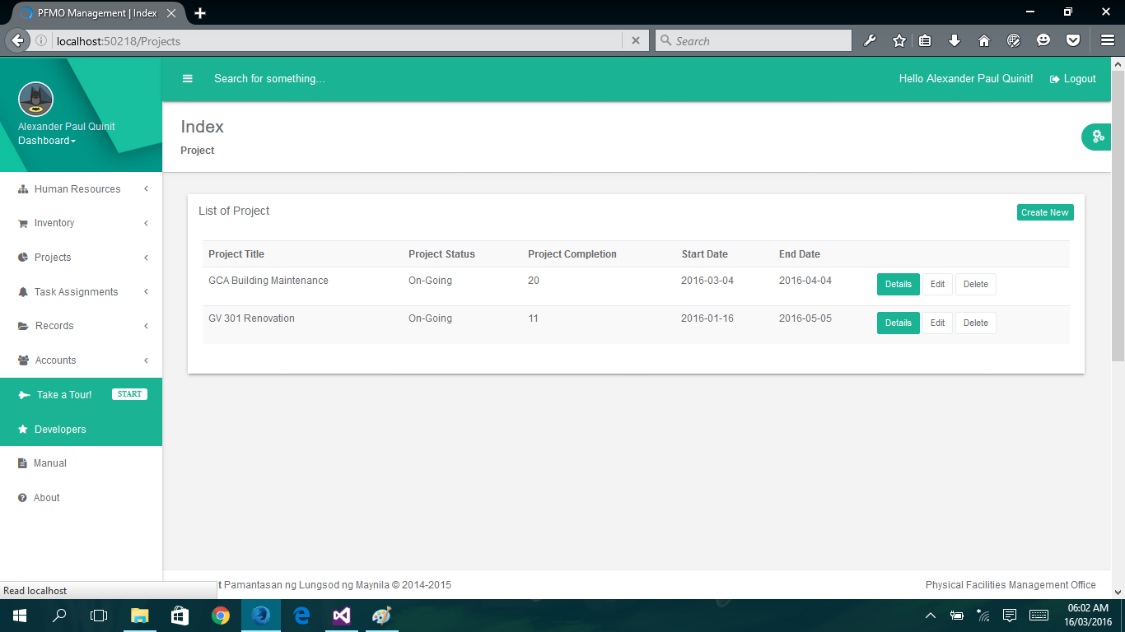

1. **Task Assignments**

**Section Tasks**

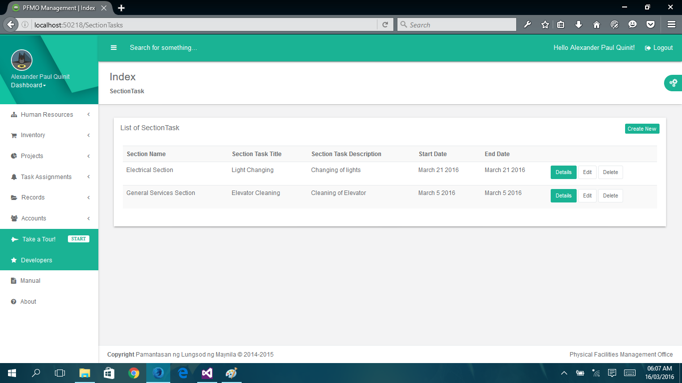

**Personnel Task**

